**Machine Learning Project Report**

On

**Kaggle’s**

**Google Analytics Customer Revenue Prediction**

Hieu Trung Tran: txt171930

Rutali Bandivadekar: rdb170002

Pallavi Pandey: pxp170009

# Contents

|  |  |  |
| --- | --- | --- |
|  | Topics | Page Number |
| 1. | Introduction & Problem Statement | 3 |
| 2. | Related Work | 4 |
| 3. | Dataset Description | 5 |
| 4. | Pre-processing techniques | 7 |
| 5. | Data Visualization | 12 |
| 6. | Proposed solution and methods | 15 |
| 7. | Experimental Results and Analysis | 19 |
| 8. | Conclusion | 28 |
| 9. | Contribution of team members | 30 |
| 10. | References | 31 |

# Topic 1

# Introduction and Problem Description

We have participated in the Kaggle Competition ‘Google Analytics Customer Revenue Prediction’. The competition provides data from the Google Merchandise Store (also known as GStore). Our goal is to develop a model that will help to predict the revenue of a customer.

We believe that this is a great opportunity for us to showcase how digital marketing can make use of data science to answer any business problem. Digital marketing can take important data insights learned from the given data to improve their marketing strategies and business to maximize their rate of return (ROI).

In our approach, we are using the exploratory data analysis for applying data science to business problem.

Competition link: <https://www.kaggle.com/c/ga-customer-revenue-prediction>

# Topic 2

# Related Work

We know that the 80/20 rule holds true for a lot of businesses. It says that it is only a small percentage of the customers that make up most of the revenue. Owing to this, the marketers face a tough task of coming up with various promotional/marketing techniques.

Through our project, the outcome that we have provided will consider better actionable changes which help the marketing managers to imply various strategies on Gstore.

We have referred a few machine learning tasks so that we have a deep insight into which machine learning tasks we should perform.

* For preprocessing and analyzing the data, we referred a few of the kernels available online on [www.kaggle.com](http://www.kaggle.com).
* The initial steps required a very large and complex data to be preprocessed and thus we referred to DataCamp’s course “Preprocessing for Machine Learning in Python” in order to clean our data for modeling.

# Topic 3

# Dataset Description

The customer dataset consists of**1708337** records. Out of these, **903653 are training samples** and remaining **804684 are the test samples**. We have total **12 features and 1 target** which is transaction revenue. The features as shown below:

**fullVisitorId**- A unique identifier for each user of the Google Merchandise Store.

**[x] channelGrouping** - The channel via which the user came to the Store.

**[x] date** - The date on which the user visited the Store.

**[x] device** - The specifications for the device used to access the Store.

**[x] geoNetwork** - This section contains information about the geography of the user.

**sessionId** - A unique identifier for this visit to the store.

**[x] socialEngagementType** - Engagement type, either "Socially Engaged" or "Not Socially Engaged".

**[x] totals** - This section contains aggregate values across the session.

**[x] trafficSource** - This section contains information about the Traffic Source from which the session originated.

**visitId** - An identifier for this session. This is part of the value usually stored as the _utmb cookie. This is only unique to the user. For a completely unique ID, you should use a combination of fullVisitorId and visitId.

**visitNumber** - The session number for this user. If this is the first session, then this is set to 1.

**visitStartTime** - The timestamp (expressed as POSIX time).

Train dataset columns

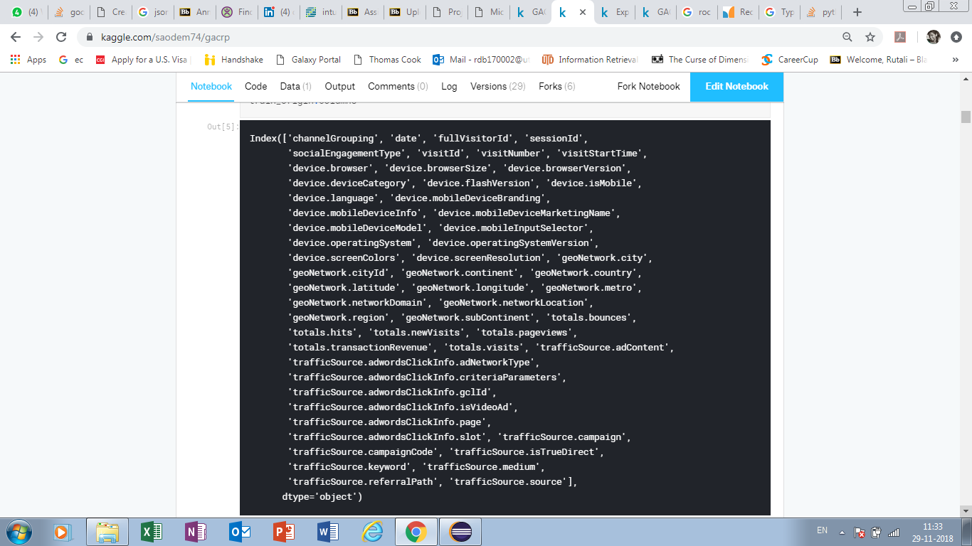

After splitting up each and all JSON columns, we have **55 features in training sample** and **53 in test sample**.

# Topic 4

# Data Preprocessing Techniques

The target we want to predict, transactionRevenue, is contained in one of the JSON columns. While loading the dataset, we renamed it to totals.transactionRevenue. The target only contains a few non-null values. Only 11515 sessions have done a transaction which is approximately 1.3% of the total observations. Therefore, we fill the NAs with zero for the column totals.transactionRevenue.

**Total.transactionRevenue plot**

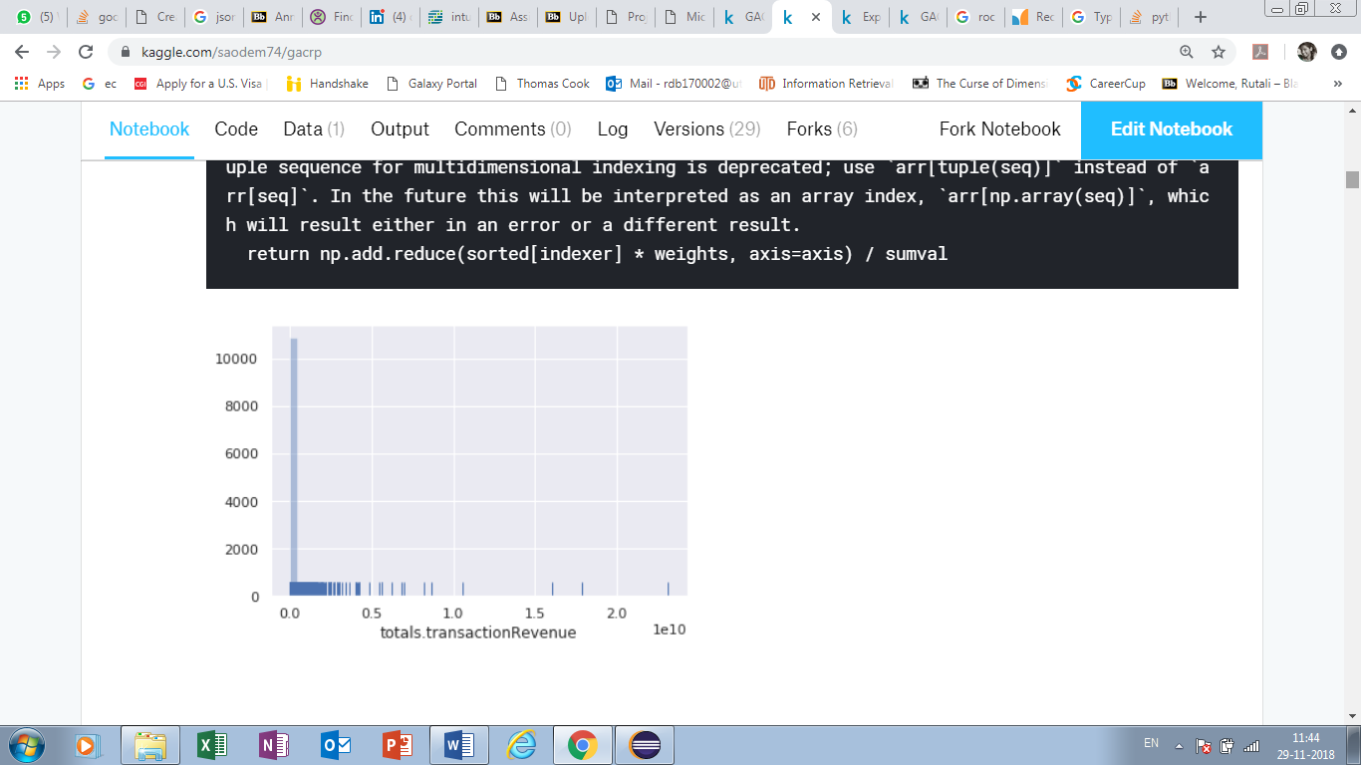

Next, we searched the columns which contain all unique and Null values. Most of the unique value columns contain Boolean data, so we replaced the null values with other Boolean data accordingly.

Fill Nan value for other attributes 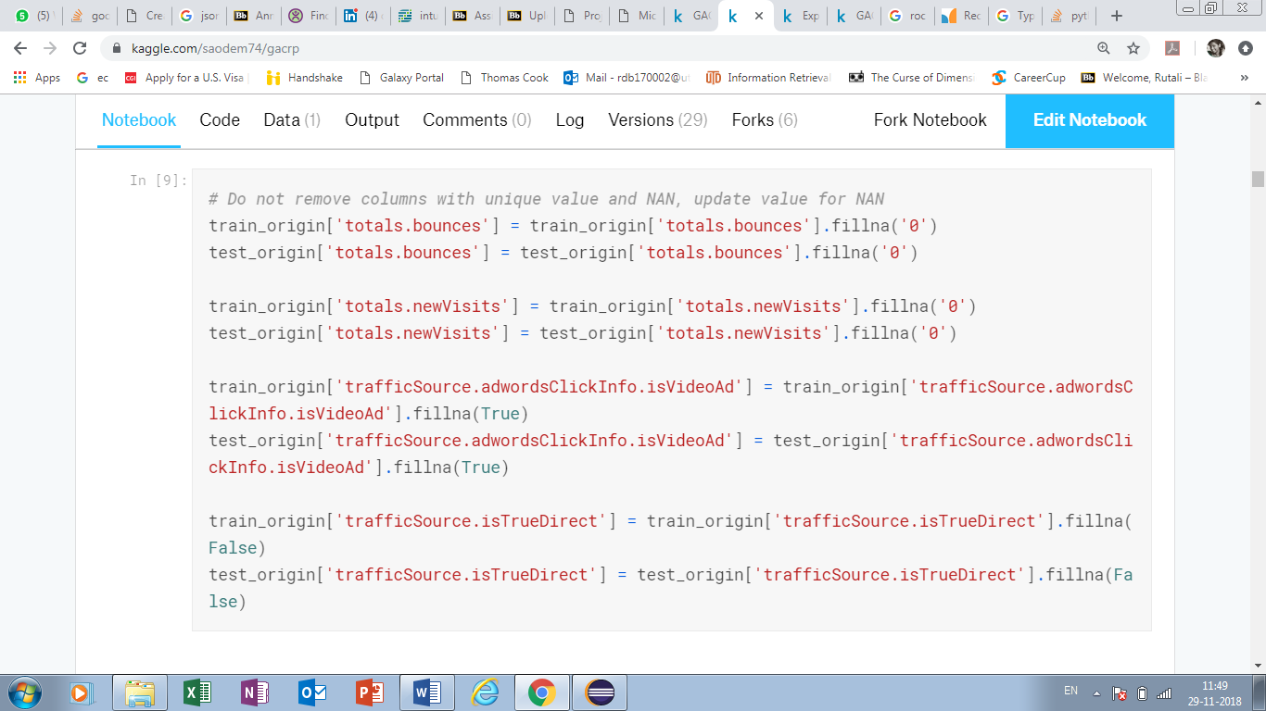

We transferred the visitStartTime into understandable formats: [day of week(0-6), hour(0-24) and day(0-30)] Thus, the number of columns got increased to 58 for training data and 56 for the test data.

**Train Original Shape, Test Original Shape**

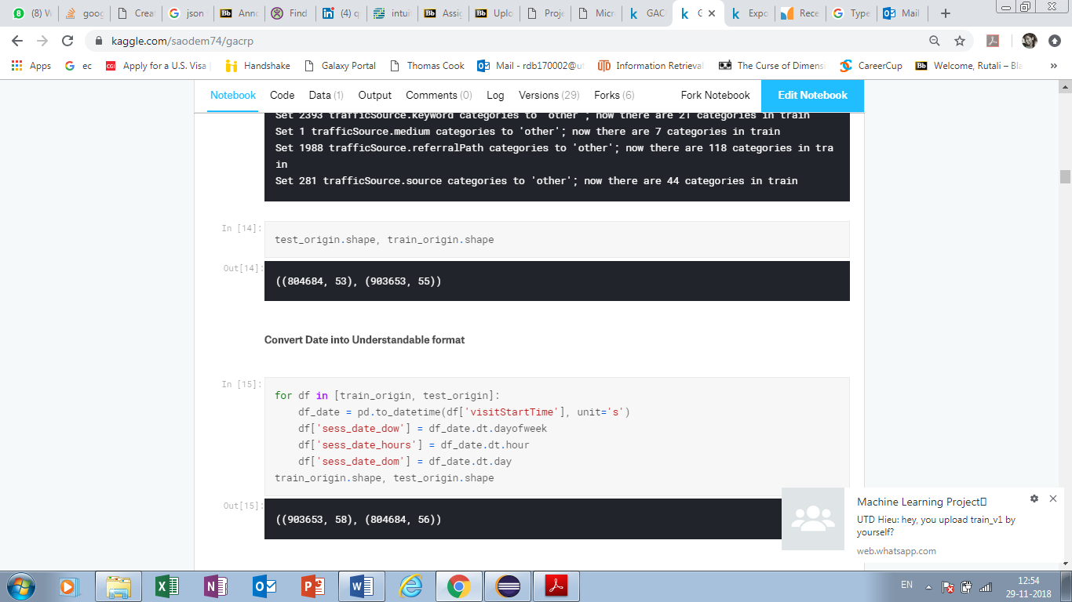

After converting visitStartTime into understandable format we have:

**Train Shape, Test Shape**



We also reduced number of rare categories for following columns:

[‘device.browser’, ‘device.operatingSystem’, ‘geoNetwork.country’, ‘geoNetwork.city’, ‘geoNetwork.metro’, ‘geoNetwork.networkDomain’, ‘geoNetwork.region’, ‘geoNetwork.subContinent’, ‘trafficSource.adContent’, ‘trafficSource.campaign’, ‘trafficSource.keyword’, ‘trafficSource.medium’, ‘trafficSource.referralPath’, ‘trafficSource.source’]

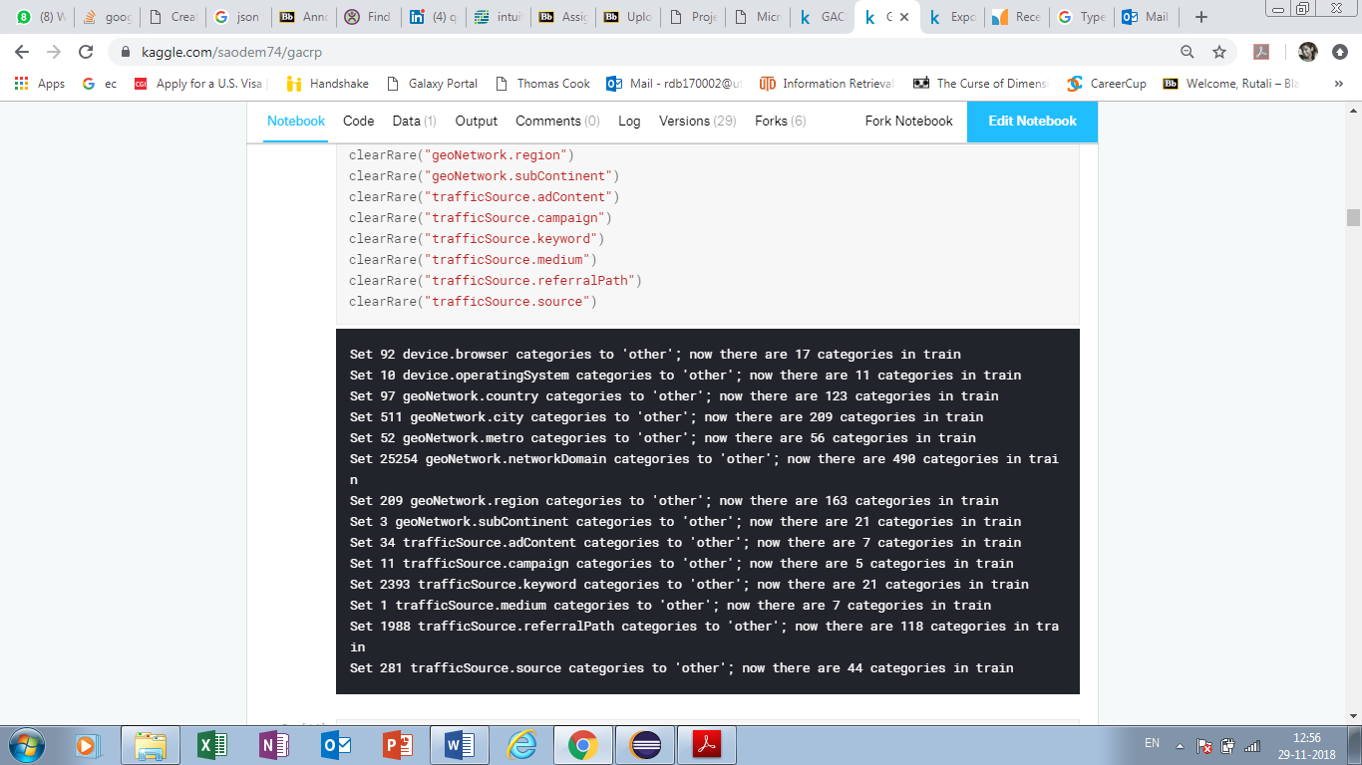

Analyzed transaction time of dataset

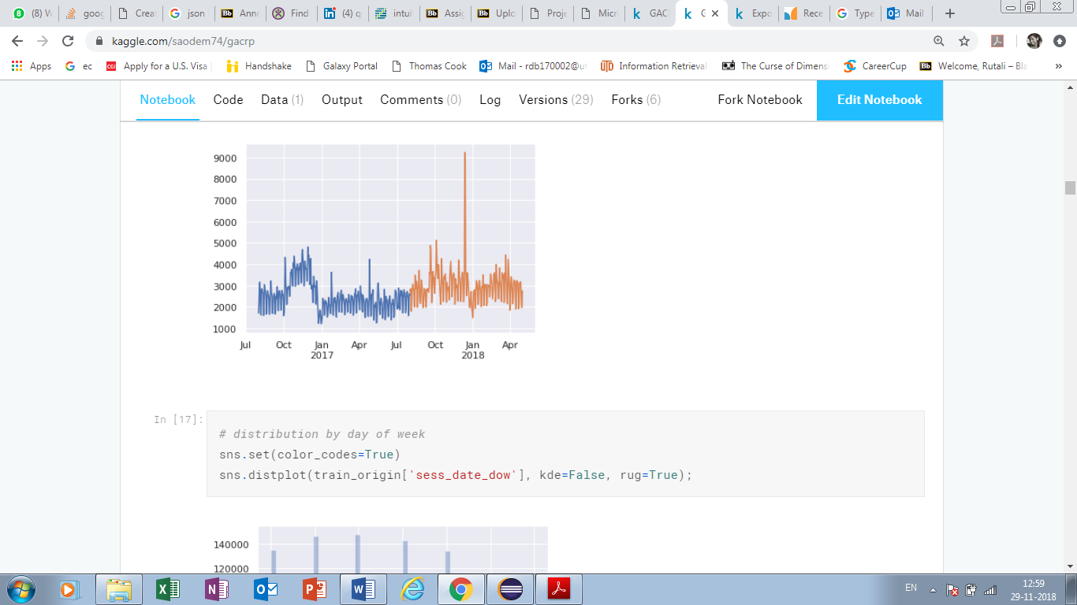

Distribution by day of week

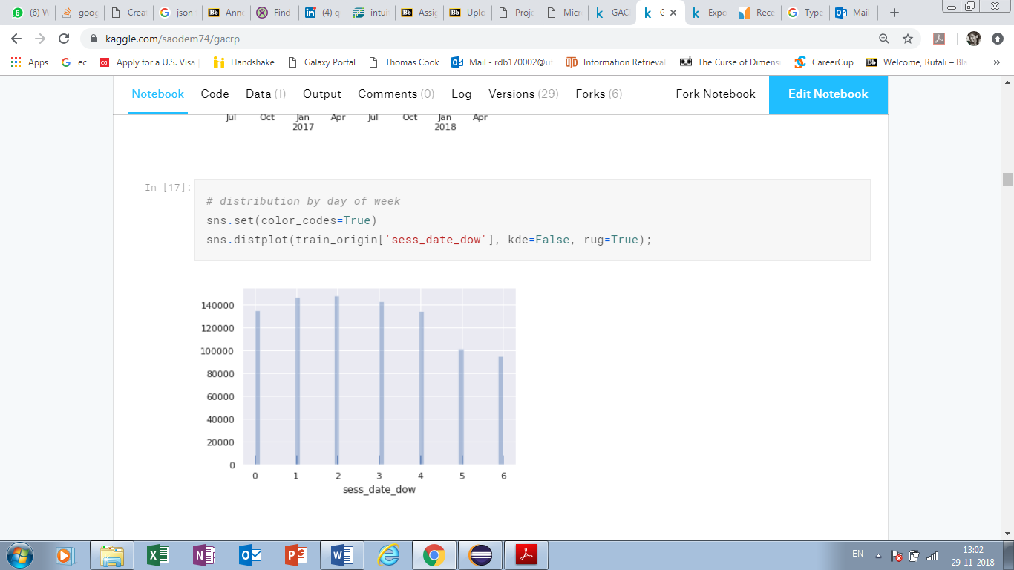

Distribution by date of week when people have done transactions

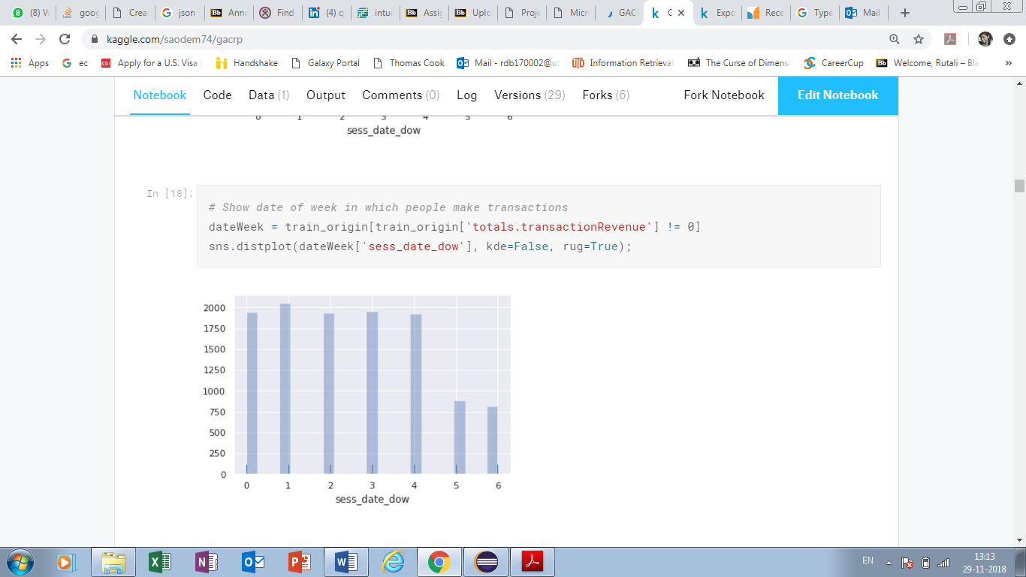

Distribution by hour of the day

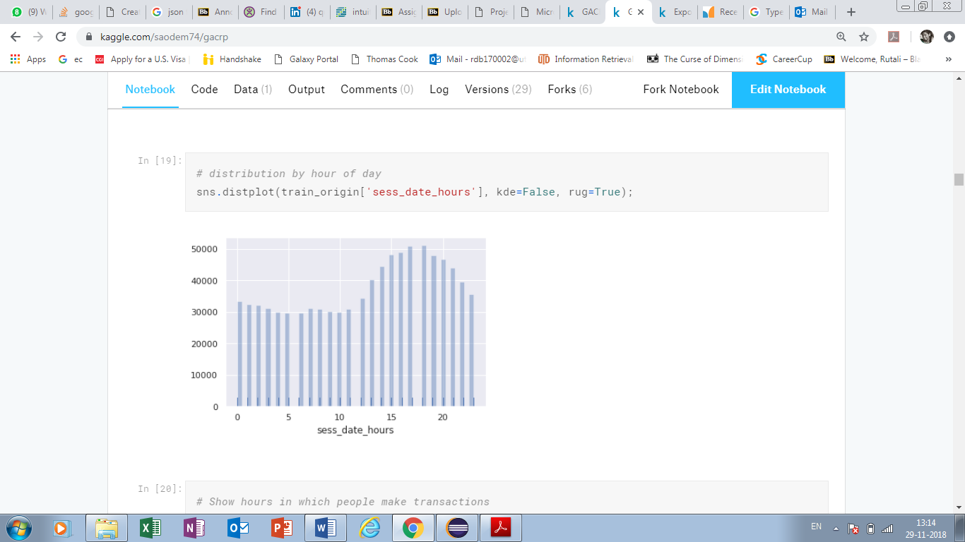

Distribution by hours when people have done transactions

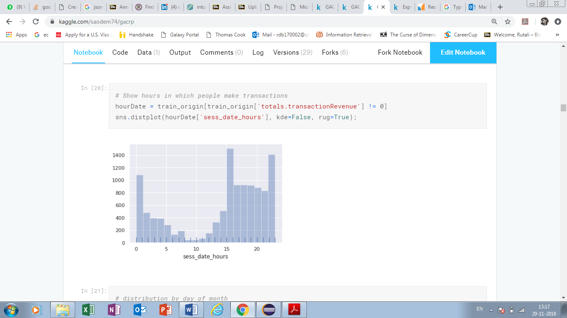

Distribution by day of month

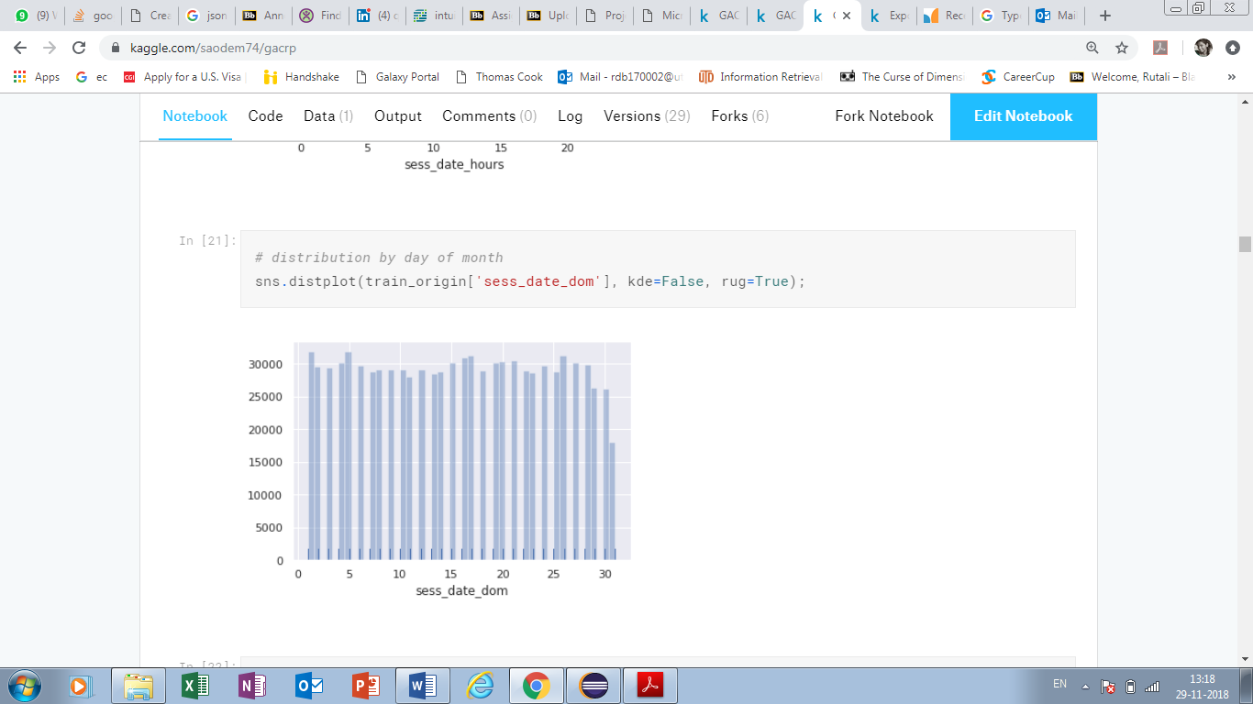

Distribution by date of month when people have done transactions

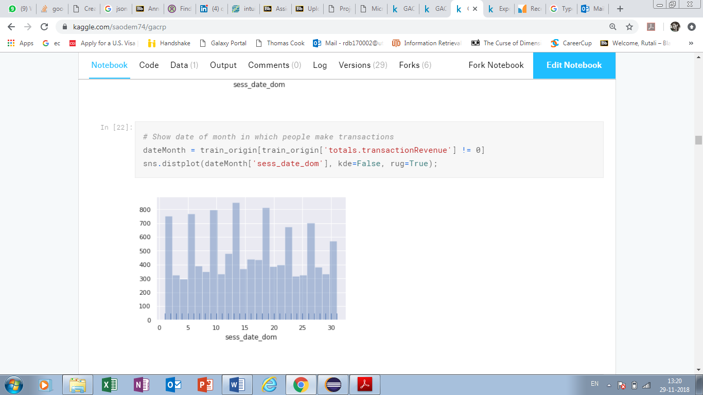

Next, we removed the columns which were either unique for all the customers or they were present only in the training data but not in the test data (only one column trafficSource.campaignCode is not present in test data). Thus, we now only have **31 features** in the training data which are given below.

['channelGrouping', 'device.browser', 'device.deviceCategory', 'device.isMobile', 'device.operatingSystem', 'geoNetwork.city', 'geoNetwork.continent', 'geoNetwork.country', 'geoNetwork.metro', 'geoNetwork.networkDomain', 'geoNetwork.region', 'geoNetwork.subContinent', 'totals.bounces', 'totals.hits', 'totals.newVisits', 'totals.pageviews', 'trafficSource.adContent', 'trafficSource.adwordsClickInfo.adNetworkType', 'trafficSource.adwordsClickInfo.gclId', 'trafficSource.adwordsClickInfo.isVideoAd', 'trafficSource.adwordsClickInfo.page', 'trafficSource.adwordsClickInfo.slot', 'trafficSource.campaign', 'trafficSource.isTrueDirect', 'trafficSource.keyword', 'trafficSource.medium', 'trafficSource.referralPath', 'trafficSource.source', 'sess_date_dow', 'sess_date_hours', 'sess_date_dom']

# Topic 5

# Data Visualization

Continent wise data count

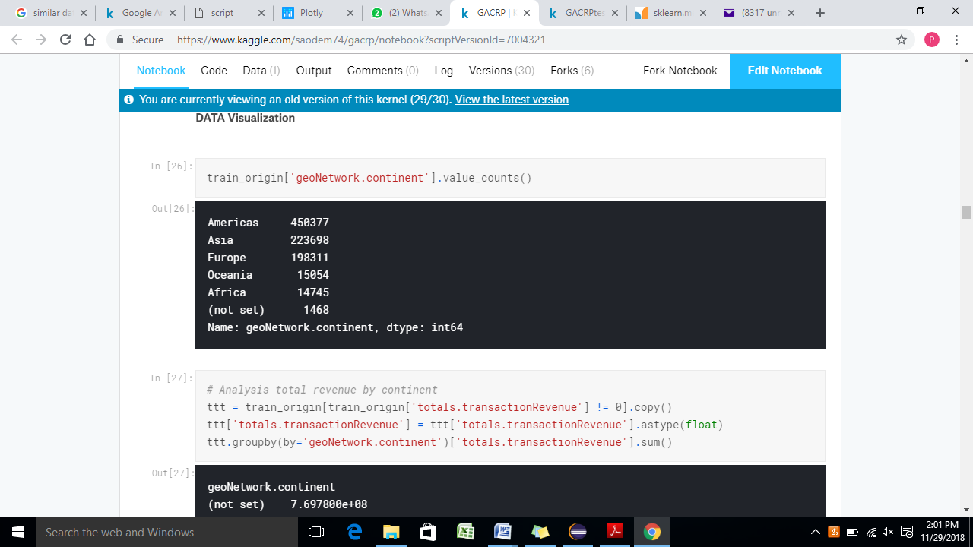

Total revenue by continent

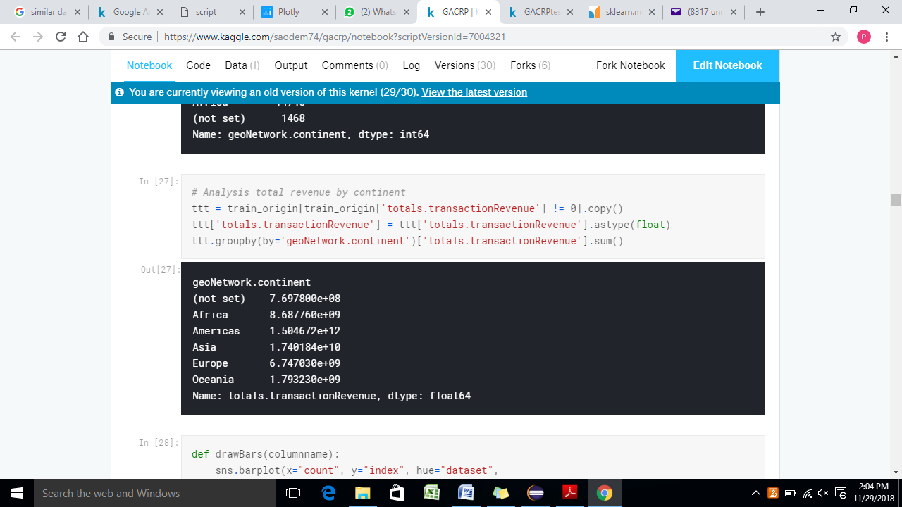

Visualization of channel grouping column

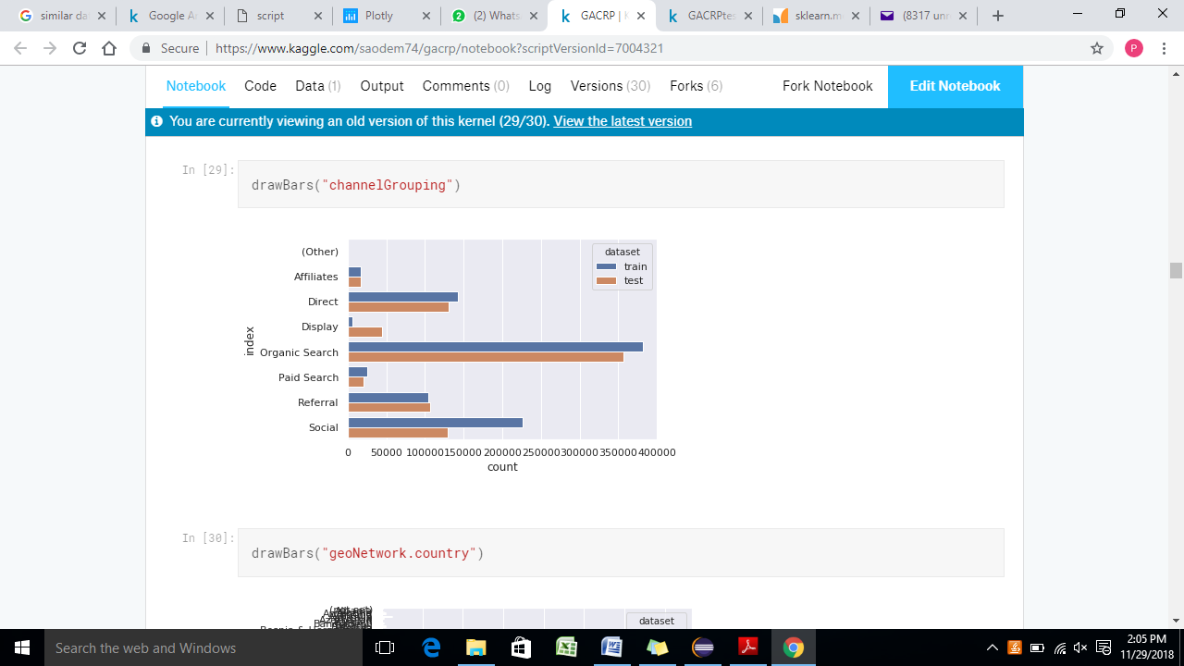

Country wise visitors count

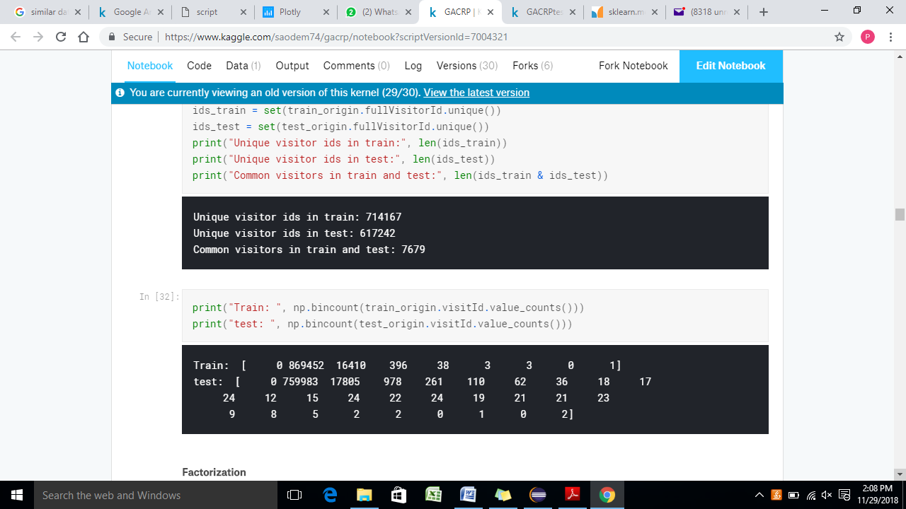

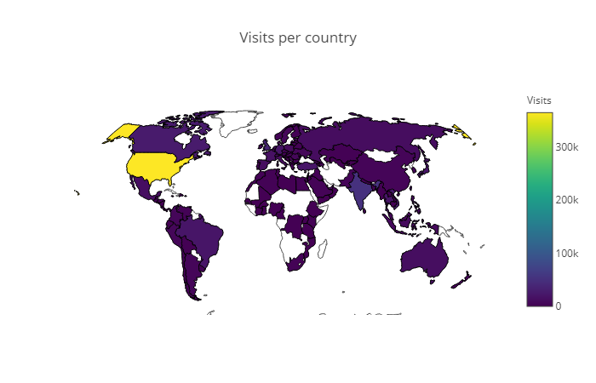

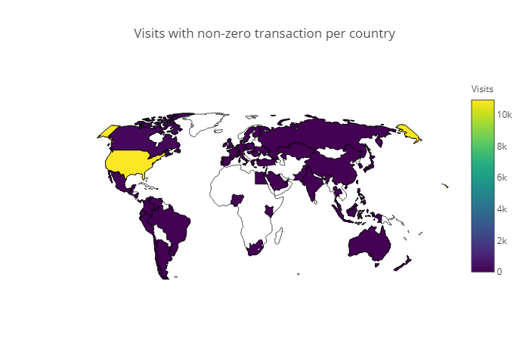

We have used PCA to visualize the dataset.

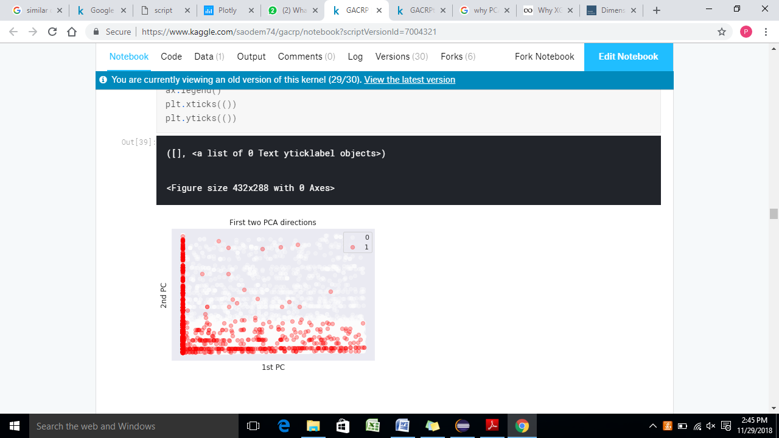

We have used PCA to reduce the dimensionality of the data as dimensionality plays a crucial role when the data consists of many features.

# Topic 6

# Proposed Solutions and Methods

We have used the following regressors to train our model

### XG Boost Classifier

### Random Forest

### Ensemble learning of Classifiers RF + XGB

### Light GBM Regressor

### CAT Regressor

### Light GBM + CAT

#### Why have we used XG Boost Classifier?

Since XG Boost has both tree learning algorithm as well as linear model solver. Thus, XG Boost can perform parallel computation on one machine.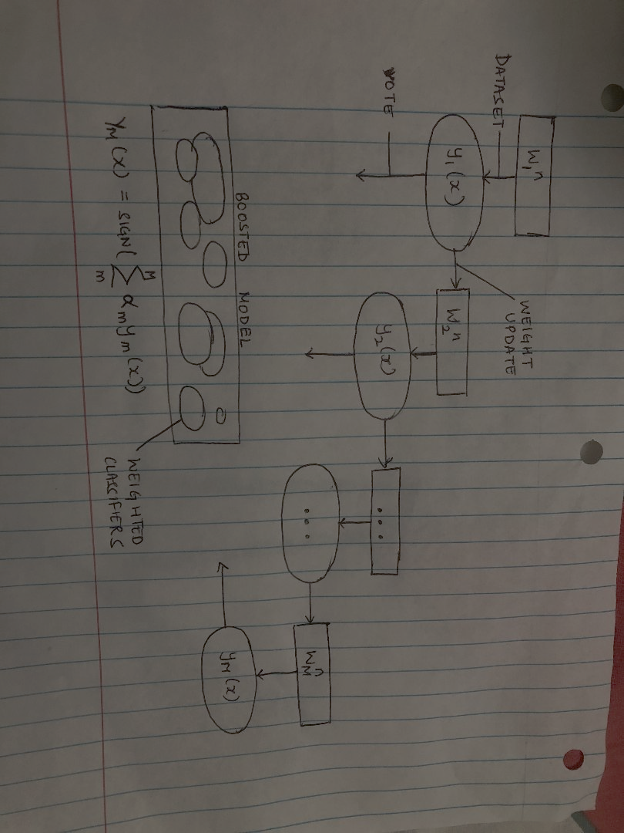

#### Why have we used CAT + light GBM?

As we already know, CAT Boosting prevents overfitting and reduces bias at a minimal cost of a varience. LightGBM consumes low memory and is faster.

#### Why have we used Random Forest?

Random Forest combines trees which are weak learners to construct a strong learner using ensemble method.

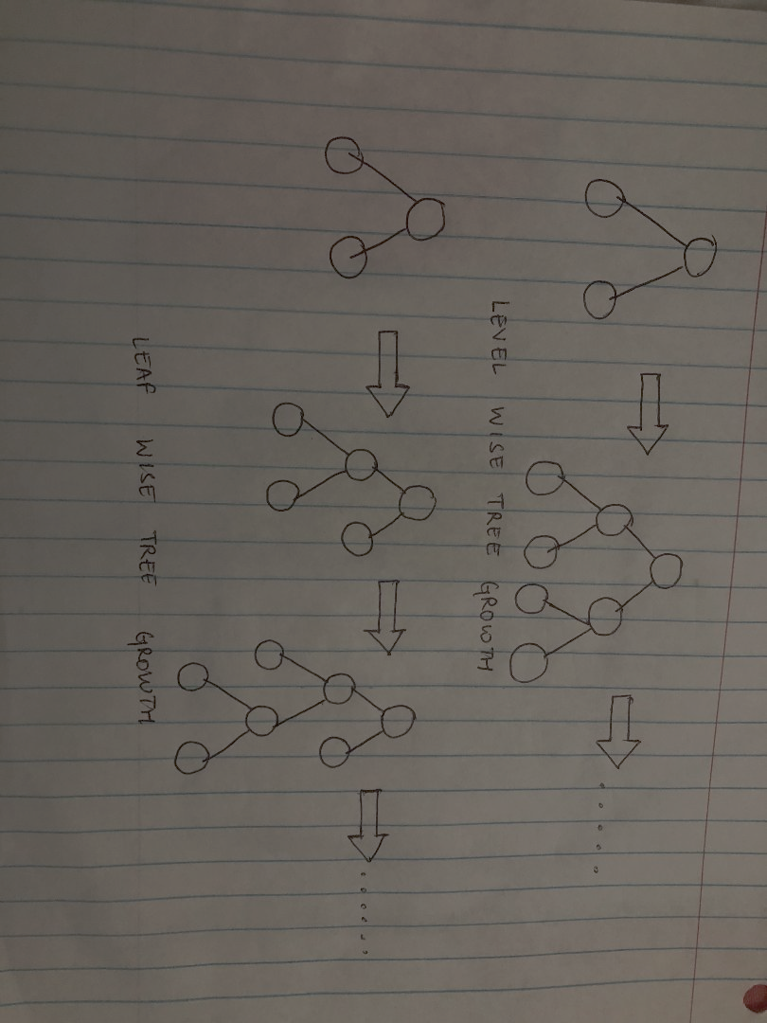

#### Why have we used Ensemble learning of Classifiers RF + XGB?

Both XG Boost and Random Forest perform random sampling and average across numerous models. This helps them reduce overfitting. Averaging across numerous models helps in fighting overfitting.

#### Why have we used Light GBM Regressor?

Light GBM Regressor is distributed, fast as well as a high-performance boosting model used for classification that makes use of Decision tree algorithm. Other boosting techniques split the tree level wise while LGBM splits a tree leaf wise giving the best fit. This reduces the loss considerably well than any other boosting technique. Below is a diagram explaining the difference between LGBM and XGBOOST classifier.

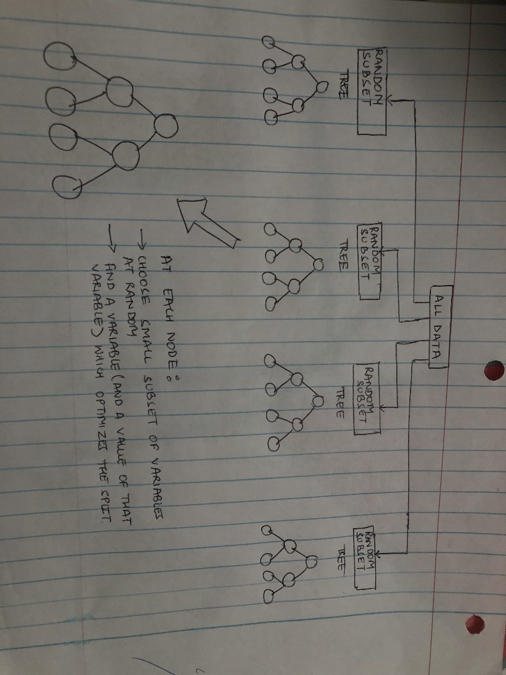

#### Why have we used CAT Regressor?

CAT Regressor reduces overfitting and the need to tune extensive hyper parameters by making the model more generalized.

# Topic 7

# Experimental Results and Analysis

## XGBoost Classifier

**Parameters used:**

'n_estimators': [100, 500, 1000]

**Best Estimator:**

XGBClassifier(base_score=0.5, booster='gbtree', colsample_bylevel=1, colsample_bytree=1, gamma=0, learning_rate=0.1, max_delta_step=0, max_depth=3, min_child_weight=1, missing=None, n_estimators=1000, n_jobs=1, nthread=None, objective='binary:logistic', random_state=0, reg_alpha=0, reg_lambda=1, scale_pos_weight=1, seed=None,

silent=True, subsample=1)

**f1 score:**

Train data: 0.399274321566256

Test data: 0.33219919579338075

**Accuracy Score:**

Train data: 0.9890071128005511

Test data: 0.9880540693074238

**ROC AUC Score:**

Train data: 0.641907814723072

Test data: 0.6170391116659173

**Confusion Matrix:**

Predicted 0 1

Actual

0 35507 185

1 459 1

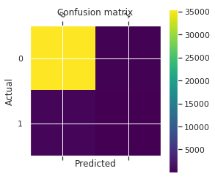

**Predicted Customer Revenue:**

|  |  |
| --- | --- |
| **fullVisitorId** | **Lgbpred** |
| 9999882818693474736 | 0.693147 |
| 9999860794386137754 | 0.000000 |
| 6059383810968229466 | 0.000000 |
| 2376720078563423631 | 0.000000 |
| 000018122977590134 | 0.000000 |

## Random Forest

**Parameters used:**

'n_estimators':[100, 500, 1000]

**Best Estimator:**

RandomForestClassifier(bootstrap=True, class_weight=None, criterion='gini', max_depth=None, max_features='auto', max_leaf_nodes=None, min_impurity_decrease=0.0, min_impurity_split=None, min_samples_leaf=1, n_samples_split=2, min_weight_fraction_leaf=0.0, n_estimators=1000, n_jobs=1, oob_score=False, random_state=None, verbose=0, warm_start=False)

**f1 score:**

Train data: 1.0

Test data: 0.2831746031746032

**Accuracy Score:**

Train data: 1.0

Test data: 0.987506293884281

**ROC AUC Score:**

Train data: 1.0

Test data: 0.5969814709072429

**Confusion Matrix**

Predicted 0 1

Actual

0 35499 193

1 459 1

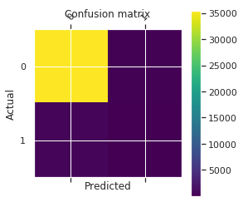

**Predicted Customer Revenue:**

|  |  |
| --- | --- |
| **fullVisitorId** | **Lgbpred** |
| 9999882818693474736 | 0.693147 |
| 9999860794386137754 | 0.000000 |
| 6059383810968229466 | 0.000000 |
| 2376720078563423631 | 0.000000 |
| 000018122977590134 | 0.693147 |

## Ensemble Learning of classifiers Random Forest + XGBoost

**Confusion Matrix**

Predicted 0.0 5136.0 10272.0

Actual

0 158502 359 175

1 2014 4 5

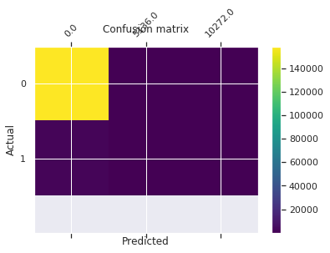

**Predicted Customer Revenue:**

|  |  |
| --- | --- |
| **fullVisitorId** | **Lgbpred** |
| 9999882818693474736 | 9.237274 |
| 9999860794386137754 | 0.000000 |
| 6059383810968229466 | 0.000000 |
| 2376720078563423631 | 0.000000 |
| 000018122977590134 | 8.544225 |

Accuracy of XGBoost and Random Forest algorithm is very high on tets data. The model seem to overfit the data. When we combine both the models, revenue increases by a large factor.

Above three models do not provide accurate prediction.

## LightGBM regressor

**Parameters used:**

n_estimators=1000, objective="regression",metric="rmse", num_leaves=31,min_child_samples=100,learning_rate=0.03,bagging_fraction=0.7,feature_fraction=0.5,bagging_frequency=5,bagging_seed=2019, subsample=.9, colsample_bytree=.9, use_best_model=True

**Root Mean Squared Error:** 1.6178543838098116

**Confusion Matrix:**

Predicted 0.000000e+00 2.033870e-07 ... 1.553394e+01 1.576198e+01

Actual ...

0.000000 17690 1 ... 1 1

14.503646 1 0 ... 0 0

14.910784 1 0 ... 0 0

15.065413 0 0 ... 0 0

15.068274 0 0 ... 0 0

15.196793 0 0 ... 0 0

... ... ... ... ... ...

19.895604 1 0 ... 0 0

19.935610 0 0 ... 0 0

20.011751 0 0 ... 0 0

20.049333 1 0 ... 0 0

20.630492 0 0 ... 0 0

20.640058 1 0 ... 0 0

20.647680 1 0 ... 0 0

20.705845 1 0 ... 0 0

20.742480 0 0 ... 0 0

20.797445 1 0 ... 0 0

20.816702 1 0 ... 0 0

20.971477 0 0 ... 0 0

20.981777 1 0 ... 0 0

21.030015 1 0 ... 0 0

21.177521 1 0 ... 0 0

21.253058 0 0 ... 0 0

22.427650 0 0 ... 0 0

[376 rows x 11396 columns]

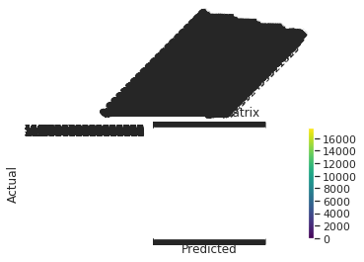

**Predicted Customer Revenue:**

|  |  |
| --- | --- |
| **fullVisitorId** | **Lgbpred** |
| 6167871330617112363 | 0.000000 |
| 0643697640977915618 | 0.000127 |
| 6059383810968229466 | 0.000289 |
| 2376720078563423631 | 0.000000 |
| 2314544520795440038 | 0.000000 |

## CAT regression model

**Parameters used:**

Iterations:1000, learning_rate=0.2, depth=5, random_seed=2019

**Root Mean Squared Error:**  1.6274764445009735

**Confusion Matrix**

Predicted 0.000000 0.000002 ... 17.055803 18.407936

Actual ...

0.000000 15945 1 ... 1 1

16.210675 1 0 ... 0 0

16.212496 0 0 ... 0 0

16.219749 0 0 ... 0 0

16.229637 1 0 ... 0 0

16.297078 1 0 ... 0 0

16.340439 0 0 ... 0 0

16.378920 1 0 ... 0 0

16.379690 1 0 ... 0 0

16.393452 0 0 ... 0 0

... ... ... ... ... ...

19.895604 0 0 ... 0 0

19.935610 1 0 ... 0 0

20.981777 0 0 ... 0 0

21.030015 0 0 ... 0 0

21.177521 1 0 ... 0 0

21.253058 0 0 ... 0 0

22.427650 0 0 ... 0 0

[376 rows x 20199 columns]

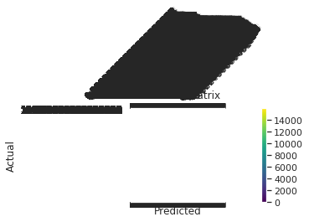

**Predicted Customer Revenue:**

|  |  |
| --- | --- |
| **fullVisitorId** | **catpred** |
| 6167871330617112363 | 0.003411 |
| 0643697640977915618 | 0.001367 |
| 6059383810968229466 | 0.004039 |
| 2376720078563423631 | 0.000000 |
| 2314544520795440038 | 0.023078 |

## Light GBM + CAT

**Root Mean Squared Error:** 1.6193379375212846

**Predicted Revenue per customer:**

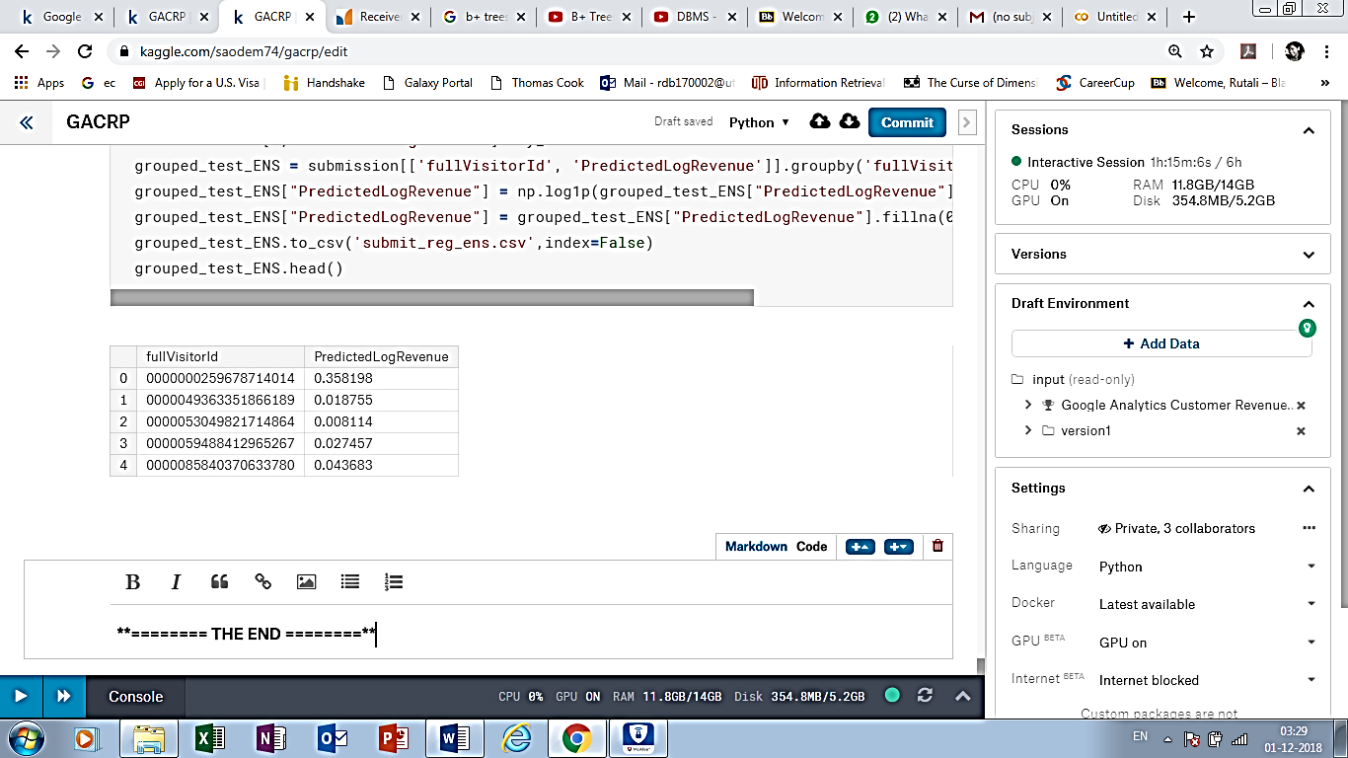

LightGBM, CAT and LightGBM + CAT give less Root Mean Squared Error than previous three results.

# Topic 7

# Conclusion

#### What are we predicting?

We are predicting the **natural log** of the sum of all transactions **per user**. Once the data is updated, as noted above, this will be for **all users in test_v1.csv for December 1st, 2018 to January 31st, 2019**. For every user in the test set, the target is:

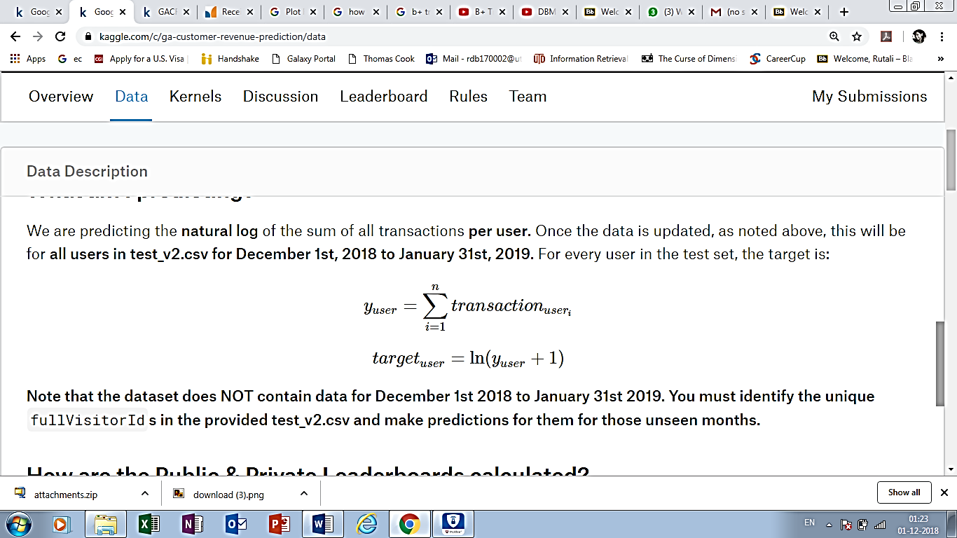

**Note that the dataset does NOT contain data for December 1st 2018 to January 31st 2019. We are identifying unique**fullVisitorId**s in the provided test_v1.csv and making predictions for them for those unseen months.**

Predicted Customer Revenue (Top 5 Customers):

|  |  |  |
| --- | --- | --- |
|  | Full Visitor id | PredictedLogRevenue |
| 1 | 0000000259678714014 | 0.358198 |
| 2 | 0000049363351866189 | 0.018755 |
| 3 | 0000053049821714864 | 0.008114 |
| 4 | 0000059488412965267 | 0.027457 |
| 5 | 0000085840370633780 | 0.043683 |

Root mean squared error (RMSE) is used to evaluate our models.

$$RMSE=\sqrt[2]{\frac{1}{n}\sum_{i=1}^{n}{{(y_{i}-{\check{y}}_{i})}^{2}}}$$

Where y hat is the natural log of the predicted revenue for a customer and y is the natural log of the actual summed revenue value plus one.

|  |  |
| --- | --- |
| **Models** | **RMSE** |
| XGBoost Classifier | **1.68** |
| Random Forest | **1.67** |
| Random Forest + XG BoostClassifier | **1.64** |
| LightGBM regressor | **1.618** |
| CAT regression | **1.623** |
| LightGBM + CAT | **1.613** |

*\*Note: for experiments using classifier models, we implemented classifier data and assign non-null value predicted by mean revenue.*

**When we combined LightGBM + CAT, we got the minimum RMSE error.**

**This model is predicting the revenue more accurately.**

# Topic 8

# Contribution of Team Members

|  |  |
| --- | --- |
| * Project idea proposal: | Hieu, Rutali, Pallavi |
| * Understanding the project: | Hieu, Rutali, Pallavi |
| * Defining the scope of the project: | Hieu, Rutali, Pallavi |
| * Research: | Hieu, Rutali, Pallavi |
| * Project Plan: | Hieu, Rutali, Pallavi |
| * Data Preprocessing and Analysis: | Hieu, Rutali, Pallavi |
| * Project Report: | Hieu, Rutali, Pallavi |
| * Running the code: | Hieu, Rutali, Pallavi |

# Topic 9

# References

* <http://blog.citizennet.com/blog/2012/11/10/random-forests-ensembles-and-performance-metrics>
* <https://www.python-course.eu/Boosting.php>
* <https://www.analyticsvidhya.com/blog/2017/06/which-algorithm-takes-the-crown-light-gbm-vs-xgboost/>
* <https://www.kaggle.com/saodem74/gacrp/data>
* <https://www.datacamp.com/courses/preprocessing-for-machine-learning-in-python>
* <https://www.kaggle.com/gpreda/google-analytics-customer-revenue-extensive-eda>
* For Map usage - <https://www.kaggle.com/gpreda/google-analytics-customer-revenue-extensive-eda>